Smooth Curvilinear Shapes
# Source: AI Source: Provided by: [Data Path: Persons Table -> ID Column: 1, Name_En Column: Motasem Essam] -> From: [ChatGPT] on [7/25/2026]
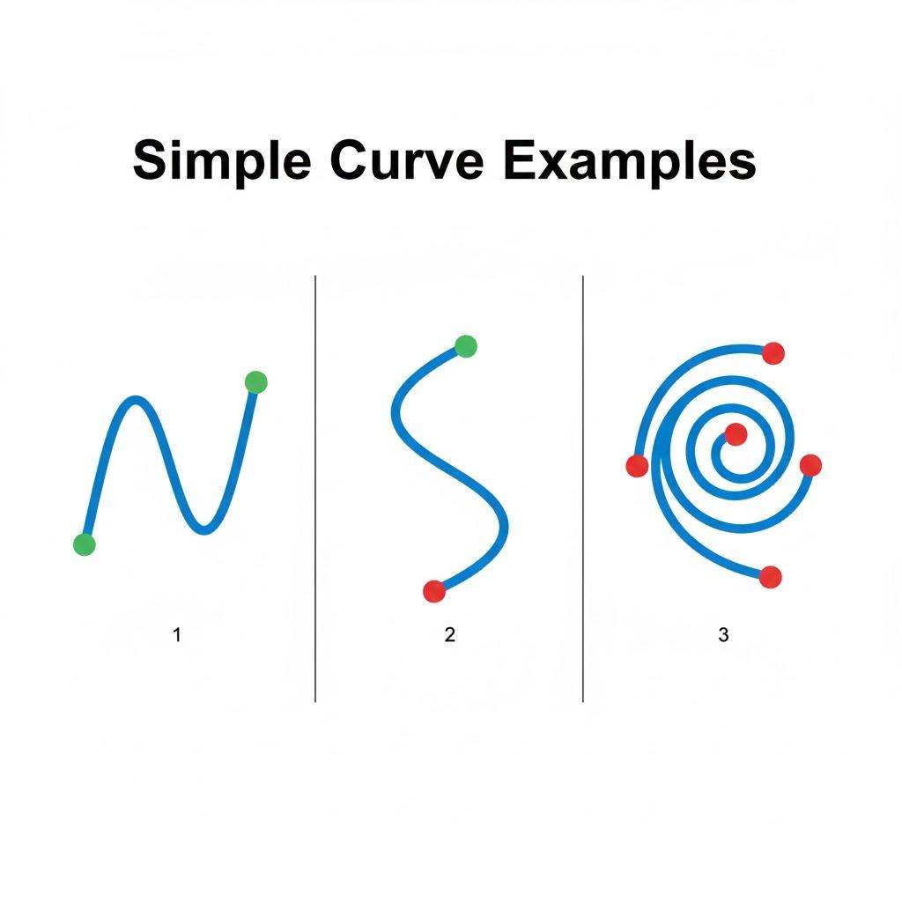
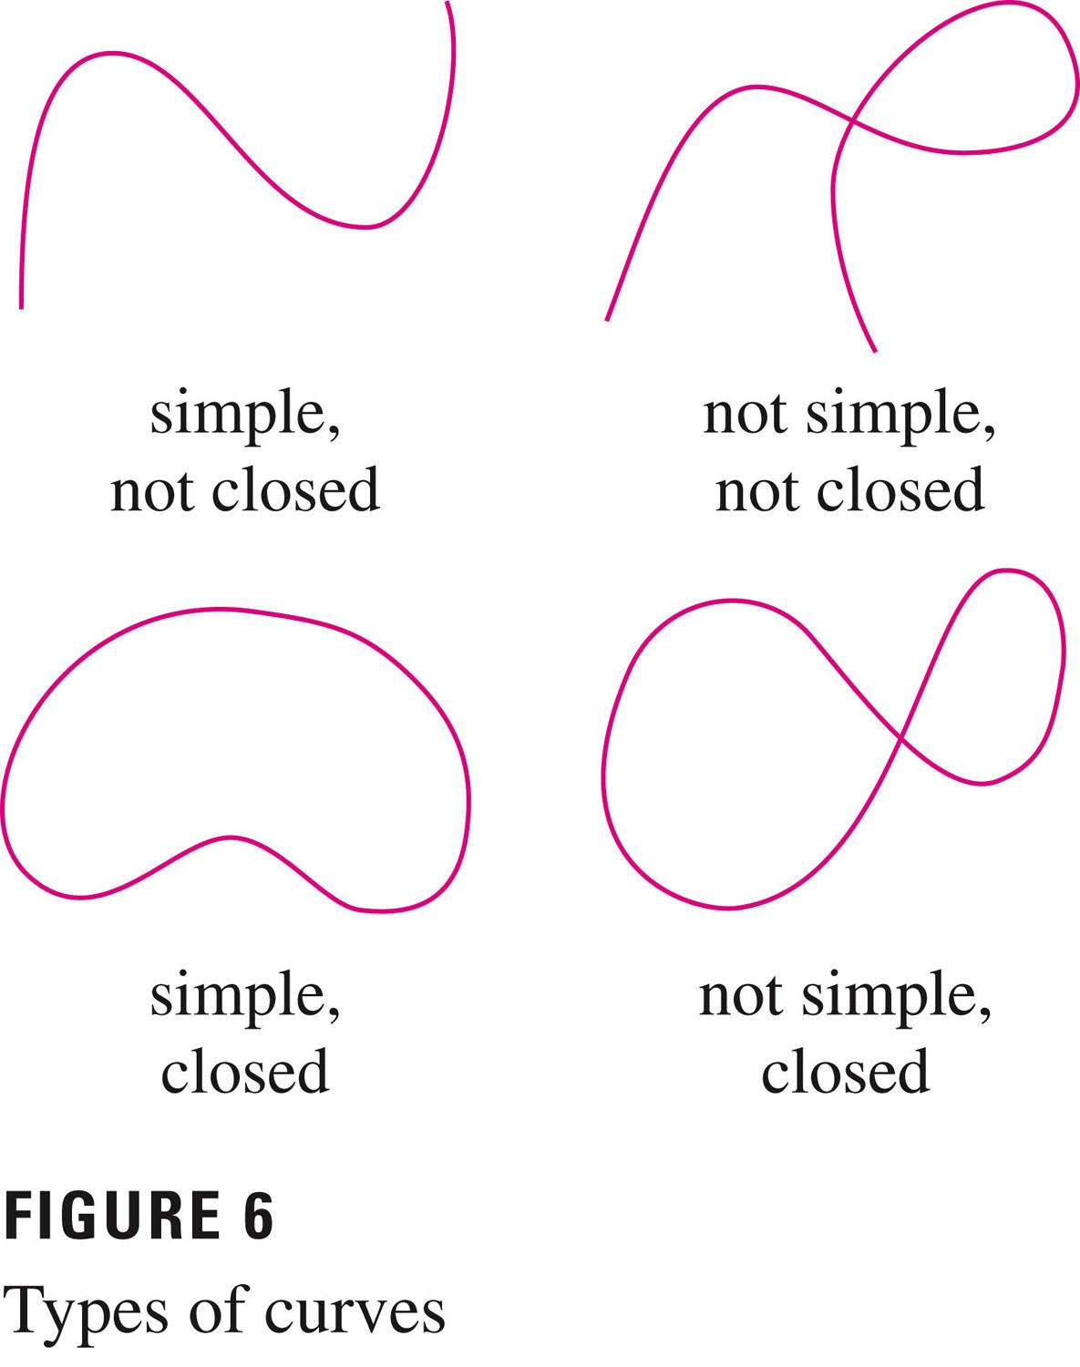
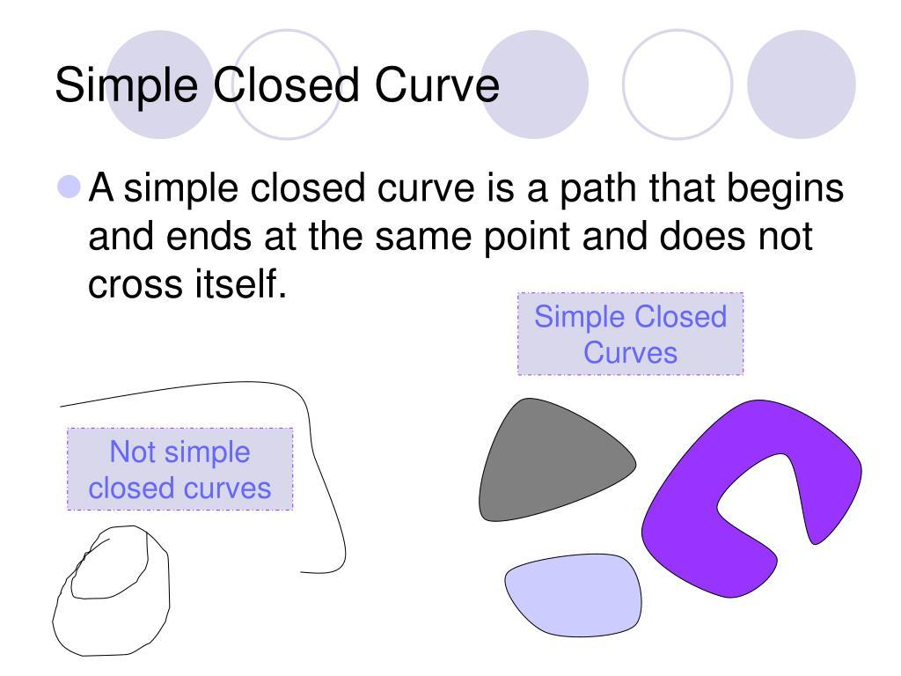
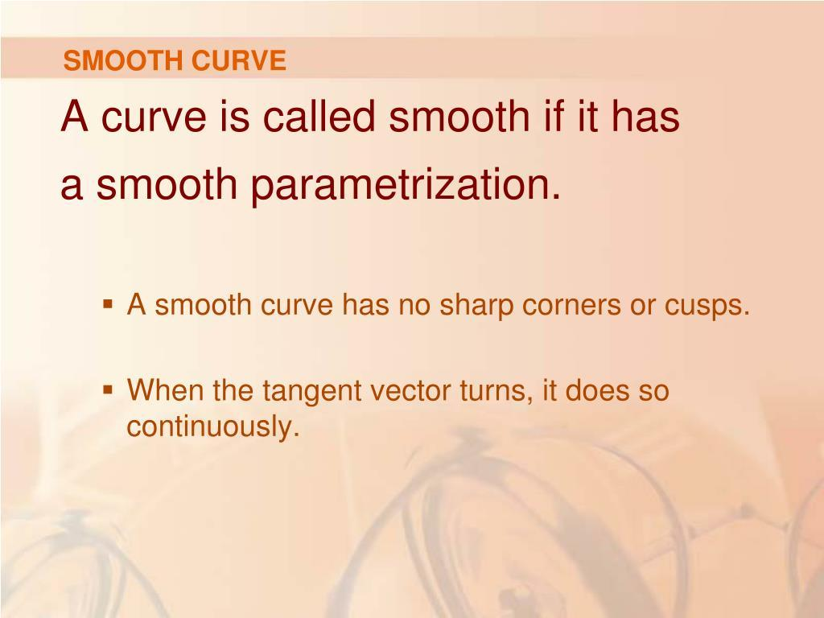
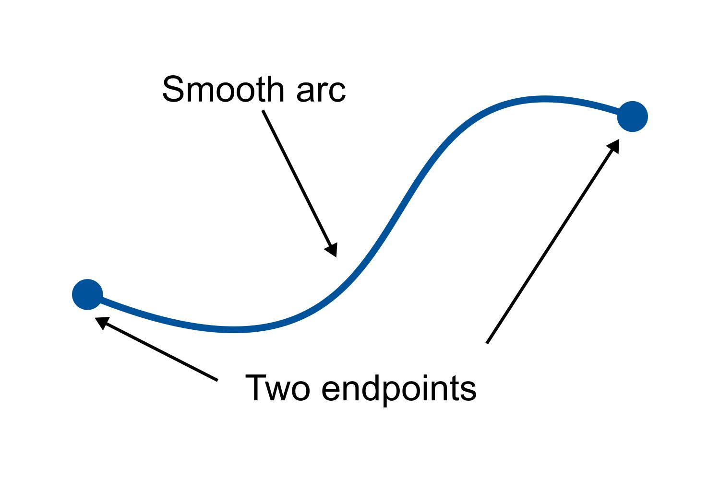
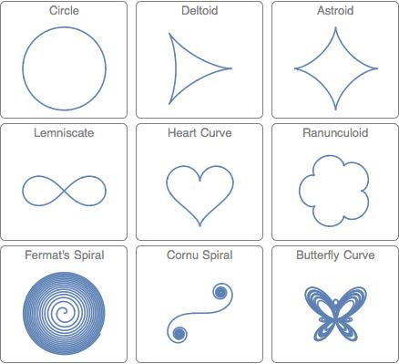

Definition
# Source: AI Source: Provided by: [Data Path: Persons Table -> ID Column: 1, Name_En Column: Motasem Essam] -> From: [ChatGPT] on [7/25/2026]
Smooth Curvilinear Shapes are shapes whose boundaries are formed primarily by smooth curves, with no abrupt corners, sharp directional changes, or discontinuities along the relevant portions of the boundary.
A smooth curve changes direction continuously. At each regular point, the curve has a well-defined tangent direction.
Smoothness is a property of the curve's continuity and differentiability, rather than a specific geometric form.

Fundamental Concept
# Source: AI Source: Provided by: [Data Path: Persons Table -> ID Column: 1, Name_En Column: Motasem Essam] -> From: [ChatGPT] on [7/25/2026]
A curve can be represented parametrically as:
$$r\left(t\right)=\left(x , \left(t\right)y\left(t\right)\right)$$
A curve is smooth over an interval when its coordinate functions have continuous first derivatives and its velocity vector does not vanish:
$$x^{'}\left(t\right),y^{'}\left(t\right)\text{ are continuous}$$
and
$$r^{'}\left(t\right)≠0$$
Thus, the curve has a continuously changing tangent direction.
Important distinction
A curve can be:
- smooth and regular
- smooth but with varying curvature
- closed and smooth
- open and smooth
- symmetric or asymmetric
Therefore, smoothness does not determine the overall shape.

Main Characteristics
# Source: AI Source: Provided by: [Data Path: Persons Table -> ID Column: 1, Name_En Column: Motasem Essam] -> From: [ChatGPT] on [7/25/2026]
Smooth curvilinear shapes generally have:
- continuously changing directions
- no sharp corners along smooth portions
- well-defined tangent directions
- continuous first derivatives
- curved boundaries
- potentially variable curvature
- potentially constant curvature
- open or closed boundaries
- symmetric or asymmetric forms
A smooth curve does not necessarily have constant curvature.
For example:
- Circle → smooth with constant curvature
- Ellipse → smooth with generally variable curvature
- S-shaped curve → smooth with variable curvature

Types of Smooth Curvilinear Shapes
# Source: AI Source: Provided by: [Data Path: Persons Table -> ID Column: 1, Name_En Column: Motasem Essam] -> From: [ChatGPT] on [7/25/2026]
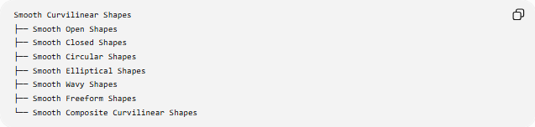
Smooth Curvilinear Shapes
├── Smooth Open Shapes
├── Smooth Closed Shapes
├── Smooth Circular Shapes
├── Smooth Elliptical Shapes
├── Smooth Wavy Shapes
├── Smooth Freeform Shapes
└── Smooth Composite Curvilinear Shapes
These categories are primarily descriptive classifications rather than a single universally standardized mathematical taxonomy.

Smooth Open Shapes
# Source: AI Source: Provided by: [Data Path: Persons Table -> ID Column: 1, Name_En Column: Motasem Essam] -> From: [ChatGPT] on [7/25/2026]
A Smooth Open Shape has a smooth boundary or path with distinct endpoints.
For a parametric curve:
$$r\left(t\right)=\left(x , \left(t\right)y\left(t\right)\right)$$
an open curve generally satisfies:
$$r\left(a\right)≠r\left(b\right)$$
Example:
●──────────────╮
╰────────────●
The curve has two endpoints and does not enclose an area by itself.
Examples
- Smooth arc
- Smooth S-curve
- Smooth wave
- Smooth freeform path

Smooth Closed Shapes
# Source: AI Source: Provided by: [Data Path: Persons Table -> ID Column: 1, Name_En Column: Motasem Essam] -> From: [ChatGPT] on [7/25/2026]
A Smooth Closed Shape has a continuous smooth boundary that returns to its starting point.
For a parametric representation:
$$\boxed{r\left(a\right)=r\left(b\right)}$$
The curve encloses a region when it is simple and closed.
Examples include:
- circle
- ellipse
- smooth oval
- smooth organic closed shape
A smooth closed curve does not have endpoints.

Smooth Circular Shapes
# Source: AI Source: Provided by: [Data Path: Persons Table -> ID Column: 1, Name_En Column: Motasem Essam] -> From: [ChatGPT] on [7/25/2026]
A Smooth Circular Shape uses circular curves or circular arcs.
For a circle:
$${\left(x-h\right)}^{2}+{\left(y-k\right)}^{2}=r^{2}$$
Its curvature is constant:
$$\boxed{κ=\frac{1}{r}}$$
Examples:
- circles
- circular arcs
- circular rings
- circular composite forms
The circle is one of the simplest examples of a smooth curvilinear shape.

Smooth Elliptical Shapes
# Source: AI Source: Provided by: [Data Path: Persons Table -> ID Column: 1, Name_En Column: Motasem Essam] -> From: [ChatGPT] on [7/25/2026]
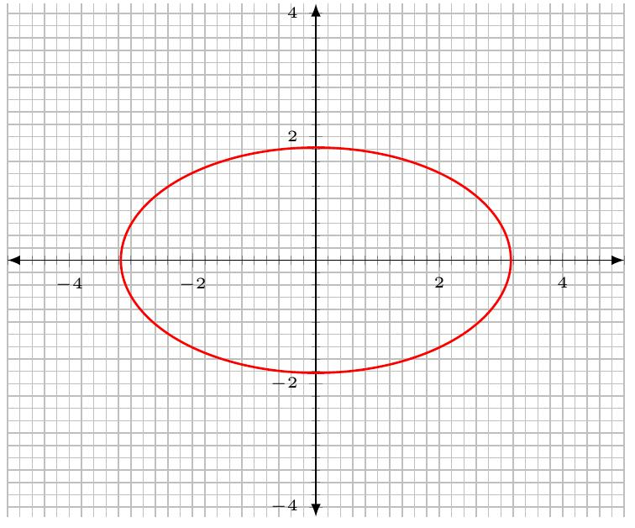
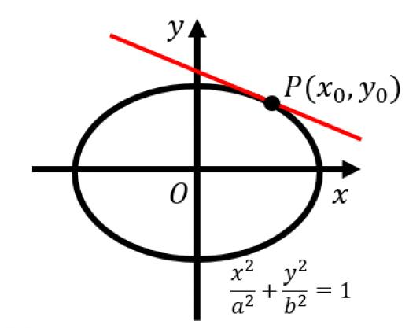
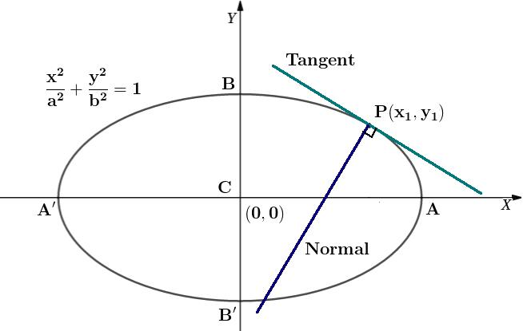
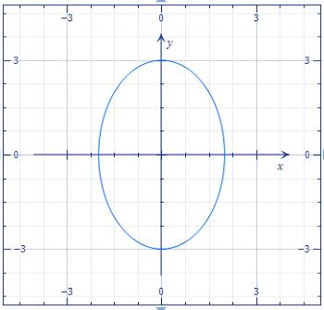
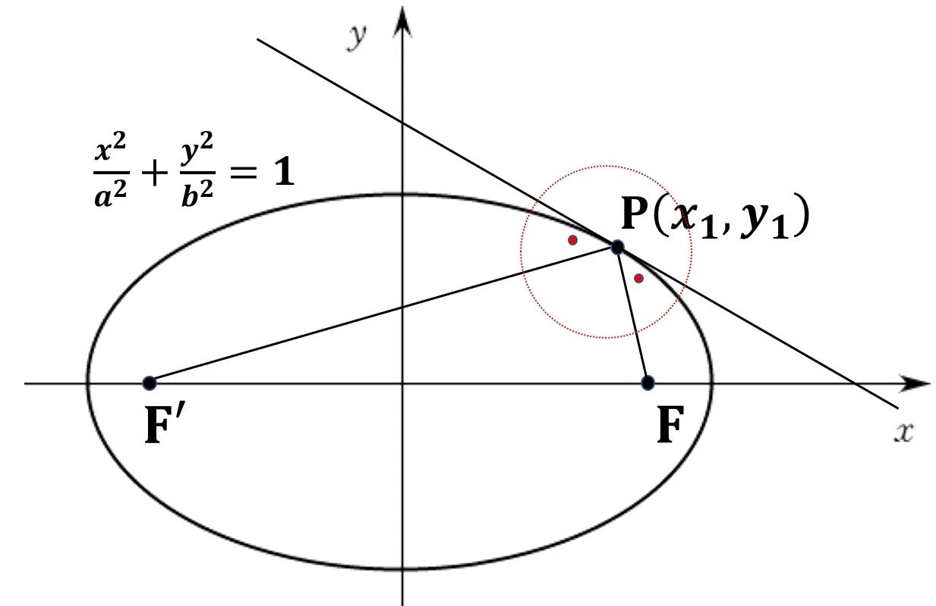
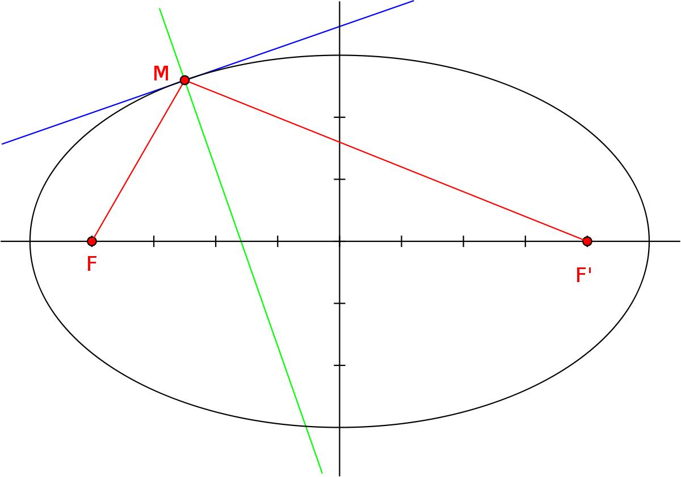
A Smooth Elliptical Shape is based on an ellipse or elliptical arcs.
A standard ellipse is:
$$\frac{{\left(x-h\right)}^{2}}{a^{2}}+\frac{{\left(y-k\right)}^{2}}{b^{2}}=1$$
Its parametric form is:
$$x=h+a\cos{t} \\ y=k+b\sin{t}$$
The ellipse is smooth, but unlike the circle, its curvature generally varies around the boundary.

Smooth Wavy Shapes
# Source: AI Source: Provided by: [Data Path: Persons Table -> ID Column: 1, Name_En Column: Motasem Essam] -> From: [ChatGPT] on [7/25/2026]
A Smooth Wavy Shape has a continuously curved, wave-like boundary.
A basic mathematical model is:
$$y=Asin⁡\left(Bx+C\right)+D$$
where:
- A controls amplitude
- B controls frequency
- C controls horizontal phase
- D controls vertical displacement
A smooth sinusoidal curve has no sharp corners.
Examples include:
- sine waves
- smooth periodic waves
- smooth flowing curves
- smooth wave-shaped boundaries

Smooth Freeform Shapes
# Source: AI Source: Provided by: [Data Path: Persons Table -> ID Column: 1, Name_En Column: Motasem Essam] -> From: [ChatGPT] on [7/25/2026]
A Smooth Freeform Shape uses smooth curves without following a fixed standard geometric form.
For example:
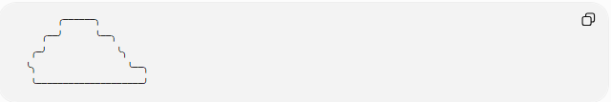
╭──────╮
╭──╯ ╰──╮
╭─╯ ╰╮
╰╮ ╰──╮
╰────────────────────╯
The exact shape may be defined using:
- parametric curves
- spline curves
- Bézier curves
- polynomial functions
- other smooth mathematical functions
A cubic Bézier curve can be written as:
$$B\left(t\right)={\left(1-t\right)}^{3}P_{0}+3{\left(1-t\right)}^{2}tP_{1}+3\left(1-t\right)t^{2}P_{2}+t^{3}P_{3}$$
where:
$$0≤t≤1$$

Smooth Composite Curvilinear Shapes
# Source: AI Source: Provided by: [Data Path: Persons Table -> ID Column: 1, Name_En Column: Motasem Essam] -> From: [ChatGPT] on [7/25/2026]
A Smooth Composite Curvilinear Shape combines multiple smooth curves into one larger shape.
The curves may include:
- circular arcs
- elliptical arcs
- Bézier curves
- spline curves
- freeform curves
A key issue is how the individual curves meet.
Position continuity
Two curves meet continuously when:
$$r_{1}\left(t_{1}\right)=r_{2}\left(t_{2}\right)$$
Tangent continuity
For a visually smooth transition, their tangent directions should also agree.
Conceptually:
$$r_{1}^{'}\left(t_{1}\right)∥r_{2}^{'}\left(t_{2}\right)$$
This is commonly called G¹ continuity.
Higher-order smoothness can require matching curvature as well.

Mathematical Smoothness
# Source: AI Source: Provided by: [Data Path: Persons Table -> ID Column: 1, Name_En Column: Motasem Essam] -> From: [ChatGPT] on [7/25/2026]
Smoothness can be described using derivatives.
For a function:
$$y=f\left(x\right)$$
a curve is differentiable where:
$$f^{'}\left(x\right)$$
exists.
If the derivative varies continuously, the tangent direction changes continuously.
A stronger condition is:
$$f∈C^{1}$$
which means that both the function and its first derivative are continuous.
For even smoother behavior:
$$f∈C^{2}$$
means the function, first derivative, and second derivative are continuous.

Tangent Direction
# Source: AI Source: Provided by: [Data Path: Persons Table -> ID Column: 1, Name_En Column: Motasem Essam] -> From: [ChatGPT] on [7/25/2026]
At a point on a smooth curve, the tangent gives the instantaneous direction of the curve.
For:
$$y=f\left(x\right)$$
the slope of the tangent is:
$$\boxed{m=f^{'}\left(x\right)}$$
The tangent line at (x_0,y_0) is:
$$\boxed{y-y_{0}=f^{'}\left(x_{0}\right)\left(x-x_{0}\right)}$$
This is one of the defining mathematical features of a smooth curve.

Curvature
# Source: AI Source: Provided by: [Data Path: Persons Table -> ID Column: 1, Name_En Column: Motasem Essam] -> From: [ChatGPT] on [7/25/2026]
The curvature of a graph:
$$y=f\left(x\right)$$
is:
$$\boxed{κ=\frac{∣f^{''}\left(x\right)∣}{{\left(1+{\left[f^{'}\left(x\right)\right]}^{2}\right)}^{3/2}}}$$
Curvature measures how rapidly the direction of the curve changes.
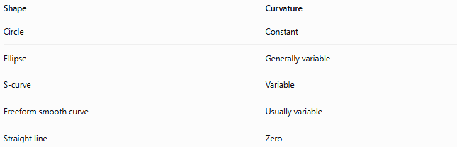
Examples
Shape | Curvature
Circle | Constant
Ellipse | Generally variable
S-curve | Variable
Freeform smooth curve | Usually variable
Straight line | Zero
Thus, smoothness and curvature are different concepts.
A curve can be smooth while its curvature changes continuously.

Arc Length
# Source: AI Source: Provided by: [Data Path: Persons Table -> ID Column: 1, Name_En Column: Motasem Essam] -> From: [ChatGPT] on [7/25/2026]
For a smooth function:
$$y=f\left(x\right)$$
between x=a and x=b, the arc length is:
$$\boxed{L=\int_{a}^{b}{\sqrt{1+{\left[f^{'}\left(x\right)\right]}^{2}}} dx}$$
For a parametric curve:
$$x=x\left(t\right), y=y\left(t\right)$$
the arc length is:
$$\boxed{L=\int_{a}^{b}{\sqrt{{\left(\frac{dx}{dt}\right)}^{2}+{\left(\frac{dy}{dt}\right)}^{2}}} dt}$$

Area of a Smooth Closed Shape
# Source: AI Source: Provided by: [Data Path: Persons Table -> ID Column: 1, Name_En Column: Motasem Essam] -> From: [ChatGPT] on [7/25/2026]
For a smooth closed curve represented parametrically by:
$$x=x\left(t\right), y=y\left(t\right)$$
the enclosed area can be calculated using:
$$\boxed{A=\frac{1}{2}\oint{(}\left.x dy-y dx\right)}$$
This is a form of Green's theorem.
It is especially useful for irregular smooth closed boundaries that do not have a simple elementary area formula.

Smooth vs Non-Smooth Curvilinear Shapes
# Source: AI Source: Provided by: [Data Path: Persons Table -> ID Column: 1, Name_En Column: Motasem Essam] -> From: [ChatGPT] on [7/25/2026]
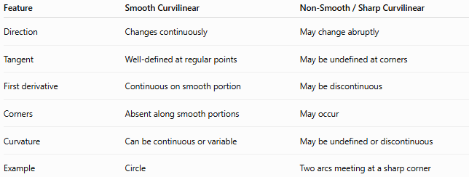
Feature | Smooth Curvilinear | Non-Smooth / Sharp Curvilinear
Direction | Changes continuously | May change abruptly
Tangent | Well-defined at regular points | May be undefined at corners
First derivative | Continuous on smooth portion | May be discontinuous
Corners | Absent along smooth portions | May occur
Curvature | Can be continuous or variable | May be undefined or discontinuous
Example | Circle | Two arcs meeting at a sharp corner
A curve can contain curved portions while still failing to be smooth at a particular point.

Smooth vs Wavy Curvilinear Shapes
# Source: AI Source: Provided by: [Data Path: Persons Table -> ID Column: 1, Name_En Column: Motasem Essam] -> From: [ChatGPT] on [7/25/2026]
These concepts overlap but are not identical.
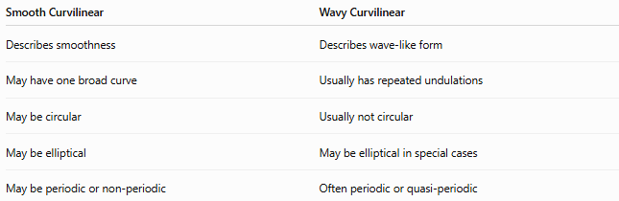
Smooth Curvilinear | Wavy Curvilinear
Describes smoothness | Describes wave-like form
May have one broad curve | Usually has repeated undulations
May be circular | Usually not circular
May be elliptical | May be elliptical in special cases
May be periodic or non-periodic | Often periodic or quasi-periodic
Therefore:
$$\boxed{\text{Wavy}≠\text{Smooth}}$$
but many wavy shapes are smooth.

Smooth vs Freeform Curvilinear Shapes
# Source: AI Source: Provided by: [Data Path: Persons Table -> ID Column: 1, Name_En Column: Motasem Essam] -> From: [ChatGPT] on [7/25/2026]
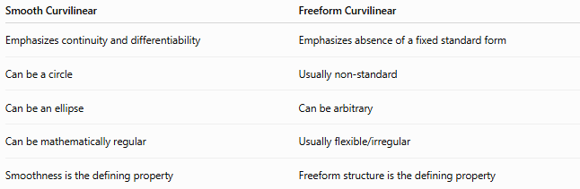
Smooth Curvilinear | Freeform Curvilinear
Emphasizes continuity and differentiability | Emphasizes absence of a fixed standard form
Can be a circle | Usually non-standard
Can be an ellipse | Can be arbitrary
Can be mathematically regular | Usually flexible/irregular
Smoothness is the defining property | Freeform structure is the defining property
A shape can therefore be both:
Smooth + Freeform
For example, a smooth Bézier-based organic shape.

Smooth vs Circular Curvilinear Shapes
# Source: AI Source: Provided by: [Data Path: Persons Table -> ID Column: 1, Name_En Column: Motasem Essam] -> From: [ChatGPT] on [7/25/2026]
A circle is always smooth, but smooth curvilinear shapes are much broader.
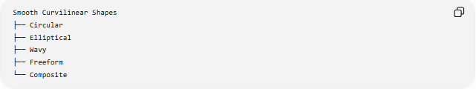
Smooth Curvilinear Shapes
├── Circular
├── Elliptical
├── Wavy
├── Freeform
└── Composite
Therefore:
$$\boxed{\text{Circular Curvilinear Shapes}⊂\text{Smooth Curvilinear Shapes}}$$
when considering complete circles and smooth circular arcs.

Classification Summary
# Source: AI Source: Provided by: [Data Path: Persons Table -> ID Column: 1, Name_En Column: Motasem Essam] -> From: [ChatGPT] on [7/25/2026]
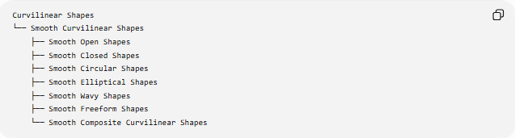
Curvilinear Shapes
└── Smooth Curvilinear Shapes
├── Smooth Open Shapes
├── Smooth Closed Shapes
├── Smooth Circular Shapes
├── Smooth Elliptical Shapes
├── Smooth Wavy Shapes
├── Smooth Freeform Shapes
└── Smooth Composite Curvilinear Shapes
A classification by mathematical structure can also be written as:
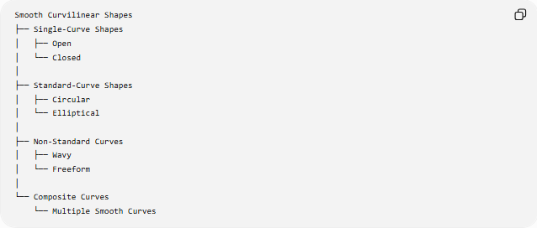
Smooth Curvilinear Shapes
├── Single-Curve Shapes
│ ├── Open
│ └── Closed
│
├── Standard-Curve Shapes
│ ├── Circular
│ └── Elliptical
│
├── Non-Standard Curves
│ ├── Wavy
│ └── Freeform
│
└── Composite Curves
└── Multiple Smooth Curves

Key Points
# Source: AI Source: Provided by: [Data Path: Persons Table -> ID Column: 1, Name_En Column: Motasem Essam] -> From: [ChatGPT] on [7/25/2026]
- Smooth Curvilinear Shapes are characterized by smoothly changing curved boundaries.
- A smooth curve generally has a continuously defined tangent direction.
- Smoothness is related to continuity and differentiability.
- Smoothness does not mean constant curvature.
- A circle has constant curvature.
- An ellipse generally has variable curvature.
- Smooth shapes may be open or closed.
- Smooth shapes may be circular, elliptical, wavy, freeform, or composite.
- Multiple curves can form a smooth composite shape when they meet with appropriate continuity.
- A shape can be simultaneously smooth, freeform, organic, and asymmetric.

Conclusion
# Source: AI Source: Provided by: [Data Path: Persons Table -> ID Column: 1, Name_En Column: Motasem Essam] -> From: [ChatGPT] on [7/25/2026]
Smooth Curvilinear Shapes form a broad class of curvilinear shapes distinguished by the continuous and gradual behavior of their curves. They include familiar forms such as circles and ellipses as well as waves, freeform curves, and composite smooth boundaries.
The key distinction is that smoothness describes how a curve behaves, while classifications such as circular, elliptical, wavy, or freeform describe what type of curve or structural form it has.

